**Supervised and Unsupervised Learning**

Supervised and Unsupervised learning are the two techniques of machine learning. But both the techniques are used in different scenarios and with different datasets. Below the explanation of both learning methods along with their difference table is given.

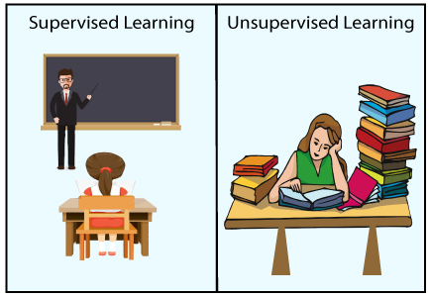

Supervised Machine Learning:

Supervised learning is a machine learning method in which models are trained using labeled data. In supervised learning, models need to find the mapping function to map the input variable (X) with the output variable (Y).

Supervised Machine learning

Supervised learning needs supervision to train the model, which is similar to as a student learns things in the presence of a teacher. Supervised learning can be used for two types of problems: **Classification** and **Regression**.

**Example:** Suppose we have an image of different types of fruits. The task of our supervised learning model is to identify the fruits and classify them accordingly. So to identify the image in supervised learning, we will give the input data as well as output for that, which means we will train the model by the shape, size, color, and taste of each fruit. Once the training is completed, we will test the model by giving the new set of fruit. The model will identify the fruit and predict the output using a suitable algorithm.

Unsupervised Machine Learning:

Unsupervised learning is another machine learning method in which patterns inferred from the unlabeled input data. The goal of unsupervised learning is to find the structure and patterns from the input data. Unsupervised learning does not need any supervision. Instead, it finds patterns from the data by its own.

Unsupervised learning can be used for two types of problems: **Clustering** and **Association**.

**Example:** To understand the unsupervised learning, we will use the example given above. So unlike supervised learning, here we will not provide any supervision to the model. We will just provide the input dataset to the model and allow the model to find the patterns from the data. With the help of a suitable algorithm, the model will train itself and divide the fruits into different groups according to the most similar features between them.

The main differences between Supervised and Unsupervised learning are given below:

|  |  |
| --- | --- |
| **Supervised Learning** | **Unsupervised Learning** |
| Supervised learning algorithms are trained using labeled data. | Unsupervised learning algorithms are trained using unlabeled data. |
| Supervised learning model predicts the output. | Unsupervised learning model finds the hidden patterns in data. |
| In supervised learning, input data is provided to the model along with the output. | In unsupervised learning, only input data is provided to the model. |
| The goal of supervised learning is to train the model so that it can predict the output when it is given new data. | The goal of unsupervised learning is to find the hidden patterns and useful insights from the unknown dataset. |
| Supervised learning needs supervision to train the model. | Unsupervised learning does not need any supervision to train the model. |
| Supervised learning can be categorized in **Classification** and **Regression** problems. | Unsupervised Learning can be classified in **Clustering** and **Associations** problems. |
| Supervised learning can be used for those cases where we know the input as well as corresponding outputs. | Unsupervised learning can be used for those cases where we have only input data and no corresponding output data. |
| Supervised learning model produces an accurate result. | Unsupervised learning model may give less accurate result as compared to supervised learning. |
| Supervised learning is not close to true Artificial intelligence as in this, we first train the model for each data, and then only it can predict the correct output. | Unsupervised learning is more close to the true Artificial Intelligence as it learns similarly as a child learns daily routine things by his experiences. |
| It includes various algorithms such as Linear Regression, Logistic Regression, Decision tree, etc. | It includes various algorithms such as Clustering, K-Means etc. |